Azure virtual networks

 Azure virtual networks will have outbound internet connectivity by default.

 Default behavior is vm with public ip gets internet access and can be accessed from internet and vm without public gets internet access but cannot be accessed from internet.

Routing in Azure

 Azure has system defined routes which are enough for common scenarios.

 Azure System Defined Routing will configure  internal connectivity

 internet connectivity  Peering connectivity

 VPN & Express Route (BGP)  [Refer Here](https://learn.microsoft.com/en-us/azure/virtual-network/virtual-networks-udr-overview) for official docs

 Azure Allows us to create custom routes

Private subnets and NAT Gateways in Azure

 [Refer Here](https://azure.microsoft.com/en-in/updates/public-preview-private-subnet/) for private subnets  [Refer Here](https://learn.microsoft.com/en-us/azure/nat-gateway/nat-overview) for NAT Gateway.

Ntier architecture in AWS VPC

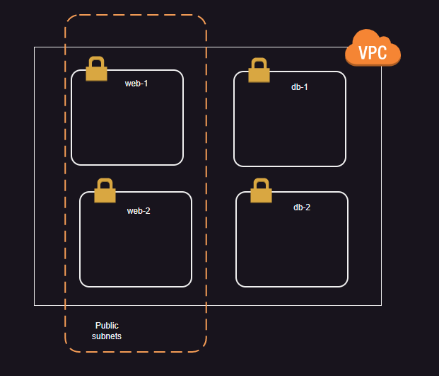

Ntier architecture in Azure Vnet

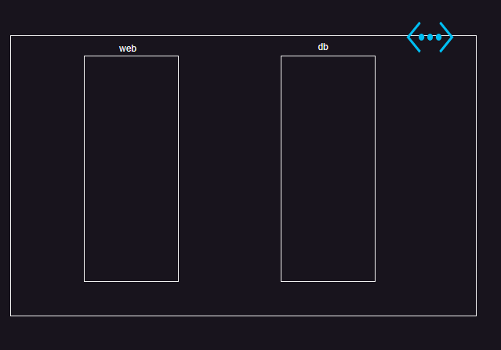

Establishing private communication between two networks (vpcs) in AWS

 Vpc Peering [Refer Here](https://docs.aws.amazon.com/vpc/latest/peering/what-is-vpc-peering.html) allows us to establish private connectivity between any two vpcs irrespective of regions or accounts.

 One rule is ip ranges should not collide with each other.  For screenshots refer classroom video

Establishing private connectivity between two virtual networks in Azure

 VNET Peering [Refer Here](https://learn.microsoft.com/en-us/azure/virtual-network/virtual-network-manage-peering?tabs=peering-portal)

Condition: IP range should not collide.